‘International Times’ the newspaper of resistance review May 2021
How Things Work: Painting
Into the Light, Mark Dunford (80pp, Tregony Gallery)
If you don’t stop to think, it’s easy to label Mark Dunford’s paintings as realist depictions of landscapes and still lives. But if you slow down and look properly you will realise that they are not realistic at all. They do engage with how things look, or are perceived, but they are as much about the act of seeing and re-presenting as what is or may be out there.
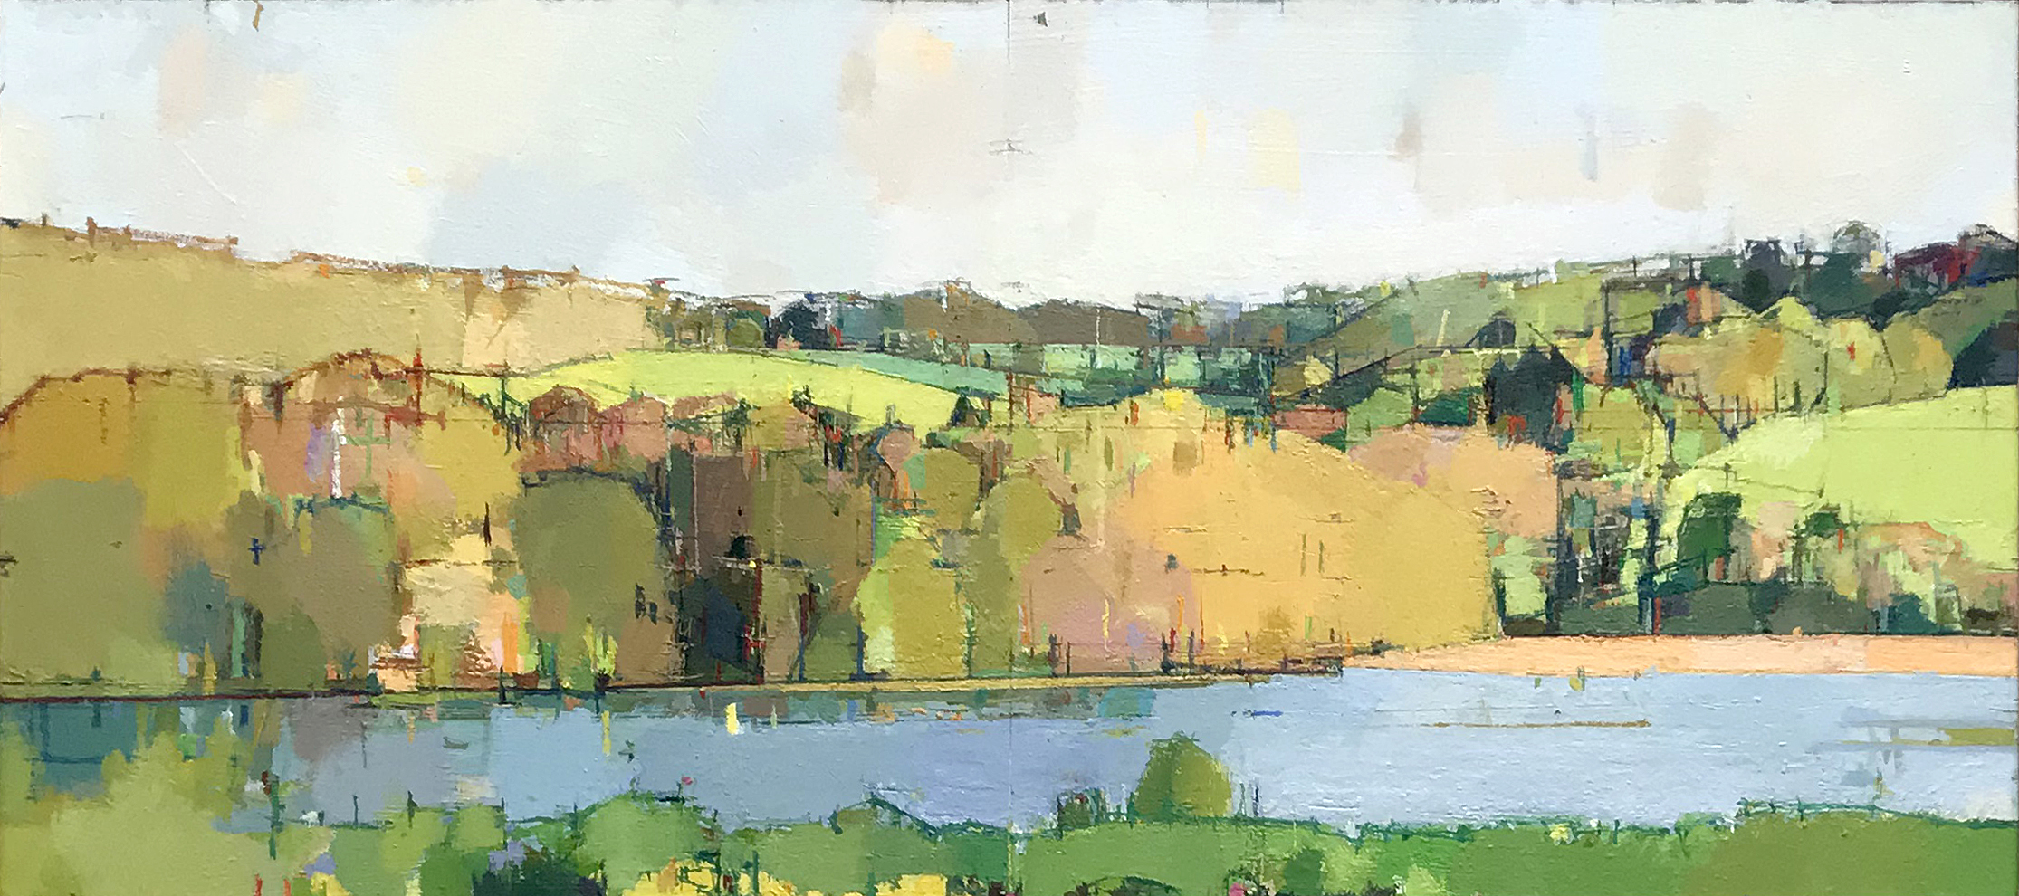
Creek Evening, Spring Light, Mark Dunford, oils on panel, 26.5 x 59 cms
The paintings evidence their construction: there are pencil grids and crosses, measured intervals and spaces, overpainting, simplification, angles and approximations. How does the light fall on this hill, how does the shadow or difference in tones create a line or shimmer over there, how to deal with the difference between daylight and dusk on the subject being studied?
This, of course, makes the work sound academic and dry, which it isn’t. Dunford’s paintings are vibrant and colourful, but they are as much about colour, form and light as the hills or flowers, trees or fields, fruit and flowers which are the ostensible ‘subject’ of the work. Dunford has considered when to simplify (areas of flat colour), when to accentuate the construction of the work, when and where to use a certain colour as light and colour change minute by minute.
Dunford takes many months, sometimes years, to paint each of his works. The book makes clear that each flower in a certain picture is a composite from several flowers over the time it takes for Dunford to capture the essence of it. In a similar way clouds or wooded areas, the water in the creek, the gardens and distant fields are configured in a certain way for maximum effect, recognition and engagement. Dr. Elizabeth Reissner suggests in her essay that ‘Dunford’s paintings are embodied responses to the world’ and that they are as much about being in the world as what the world looks like.
That is, they are far more than a reproduction or description of what is depicted. They are about the act of looking, the way light illuminates and changes, how clouds and water move, the contrast of near and far, what we can see or imagine we see, what we choose to focus on (how we ‘look’), how we feel about what we see, and about the transformation of all that into a two-dimensional approximation, selection or version.
Dunford knows in the end his work is pigment and oil placed on board or canvas, is only one interpretation of the world, a personal and tentative one. This allows him to continue making new versions, to keep looking and painting. The creek in the village he lives in, with its fields and woods beyond, its gardens, washing lines and ancient buildings, is one ongoing subject; flowers and fruit are another. Like all good artists Dunford is inquisitive and interested in the world around him, wants to understand the form and nature of what he sees and where he lives, and uses everything he can to make work that evidences his thinking and wonder.
Rupert Loydell

